Grade 9 Math
November MID-TERM EXAM PREPARATION
CHAPTER 3 – RATIONAL NUMBERS
Define the following terms:
Rational Number:_________________________________
Irrational Number:_________________________________
1. Which numbers are rational numbers? Why or why not?
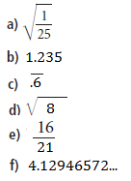

2. Write the rational number represented by each letter on the number line, as a fraction and as a decimal.
B=

A =

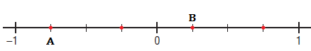
B=

C=

A =

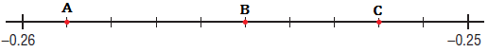
A =
B=
This one is going to make you think!!
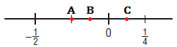
C=
3. Write 3 rational numbers between each pair of numbers. Sketch a number line to show all the rational numbers. Place them on a number line.
a) -5 and -6

b) 2.4 and 2.5

4. Order the numbers from least to greatest.
a) 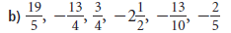

b) 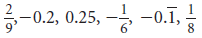

5. Find the sum.

6. Determine each product or quotient.

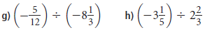

7. Evaluate
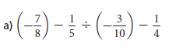

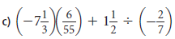

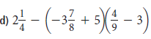

8.
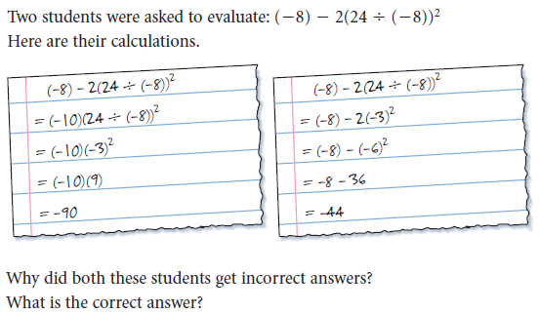

9. To pay for a skiing holiday in Whistler, Paige borrowed $1450.50 from her parents. She pays back $30.75 each week. How many weeks will it be until Paige is no longer in debt? Justify your answer

