Grade 9 Math
MID-TERM EXAM PREPARATION
CHAPTER 2 – POWERS AND EXPONENT LAWS
1. Label the diagram.
2. Fill in the blanks.
A power with an integer base and exponent 2 is a _________________
A power with an integer base and exponent 3 is a
_________________
3. Fill in the chart.
Repeated multiplication | As a power | Standard Form
6 x 6 x 6 x 6 x 6
 | (-3)³
 |  | -64
-(-10)(-10)(-10)(-10)

4. Predict whether each answer is positive or negative, then evaluate.
a) (-2)³ b) -2¹ c) (-4)⁰ d) 5¹

5. Write each number as a power with base 2.
a) 4 b) 16 c) 64

d) 256 e) 32 f) 128

6. Evaluate each power of 10.
a) 10² b) -10⁶ c) (-10)⁰

7. Fill in the chart.
Standard Form | As powers of 10
23, 409
 | (4 x 10⁷) + (5 x 10⁴) +(3 x 10³)+ (3 x 10¹)
3,210

8. Evaluate.
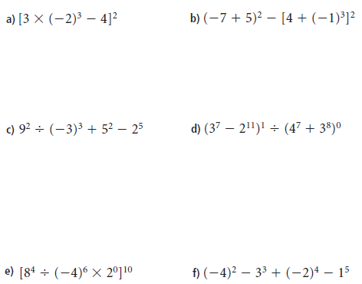

9. Use a calculator to evaluate.
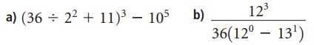

10. Write each as a single power.
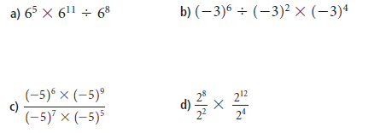

11. Evaluate
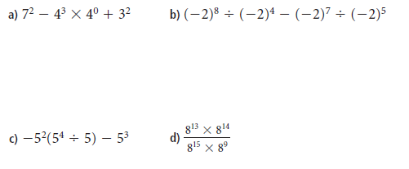.

12. Simplify by applying your exponent laws and then evaluate.

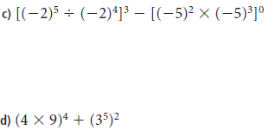
13. A wheat field is 10 000 m wide. The area of the field is 10⁸ m².
a) Use the exponent laws to determine the length of the field.

b) What is the perimeter of the field? Did you use any exponent laws to calculate the perimeter? Explain.

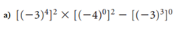
14. TRY THESE HARDER ONES!!!

