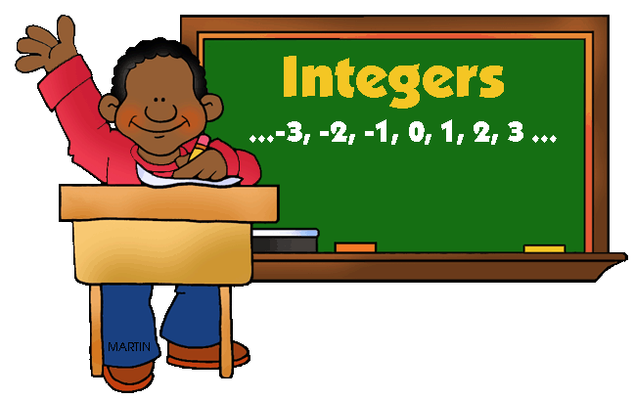

Subtraction too but when we are asked to subtract …………. we really ADD the opposite!!!!!

IF OUR SIGNS ARE THE SAME THEN WE ARE FRIENDS

Add the value of the numbers
&
the sign

examples: 4 + 6 = 10 -3 + (-11) = -14

IF OUR SIGNS ARE DIFFERENT THEN WE ARE AT WAR

THE VALUED NUMBER THE SIGN BATTLE. SUBTRACT the lower # from the higher # to see by how much.
Examples: 5 + -7 = -2 -15 + 4 = -11

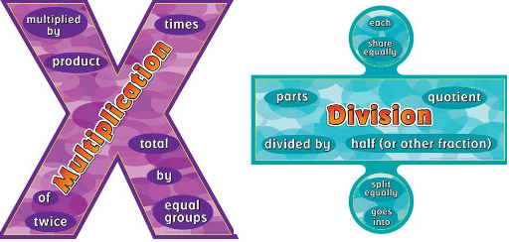
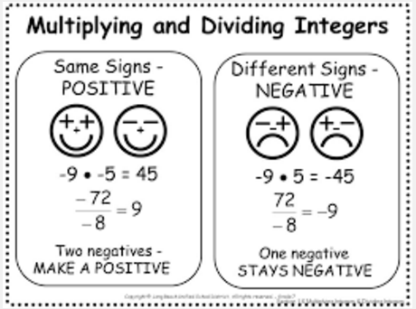

No matter what direction you read the TIC-TAC-TOE board, the last box is the answer!
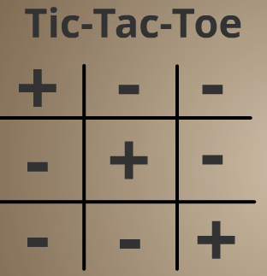

Use your finger to cover up the signs in their problem and the sign left over is the result.
