**Foundations 20 – Midterm Review Answer Key**

**Chapter 1**

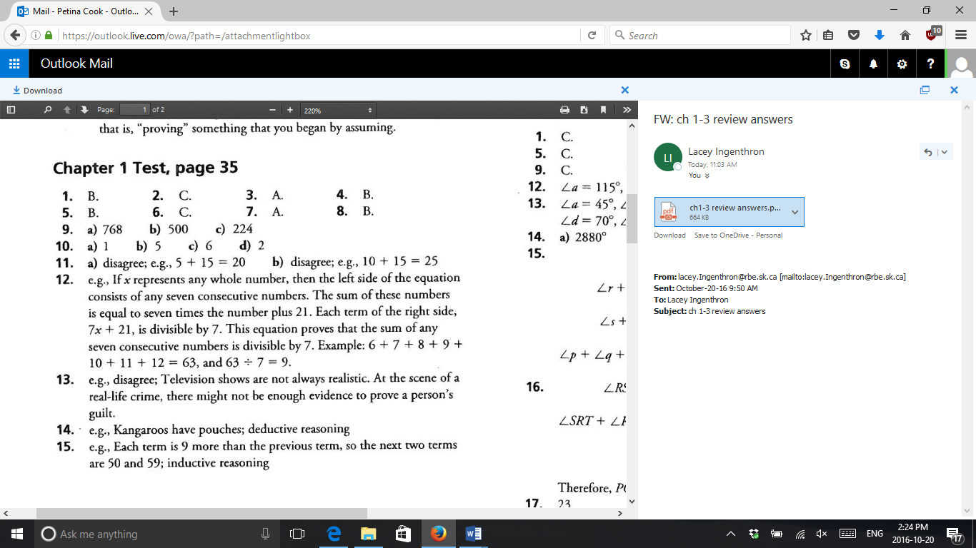

**Chapter 2**

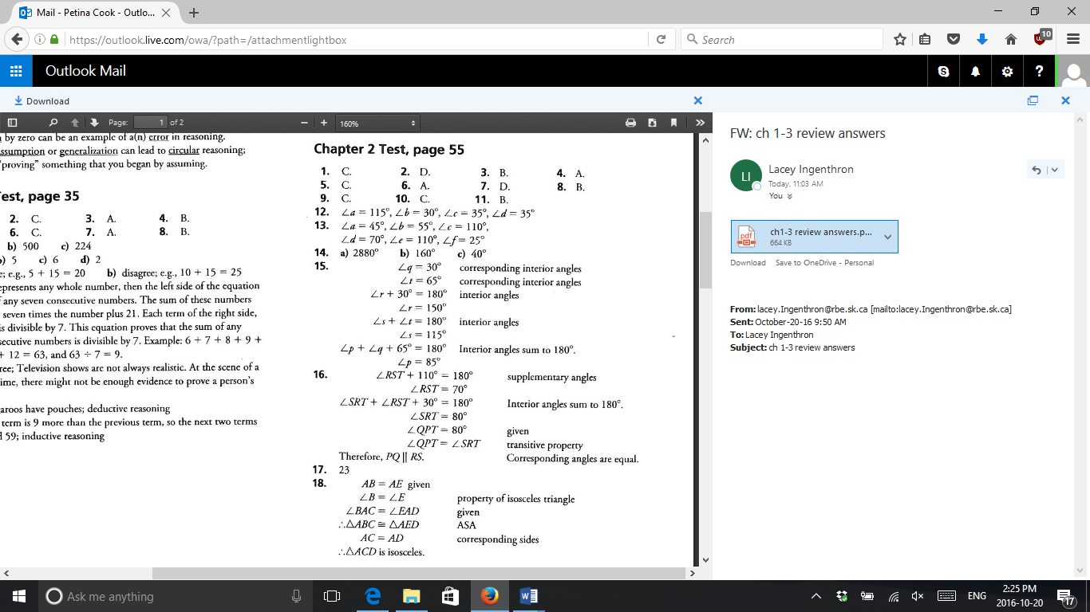

Should be 20°

**Chapter 3**

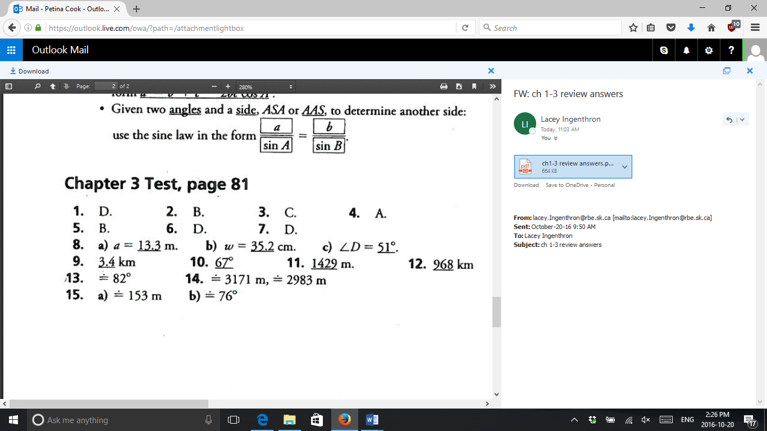

**Chapter 4**

