/60

Name

**Math Pre-Calculus 20**

**Chapter 3 Review**

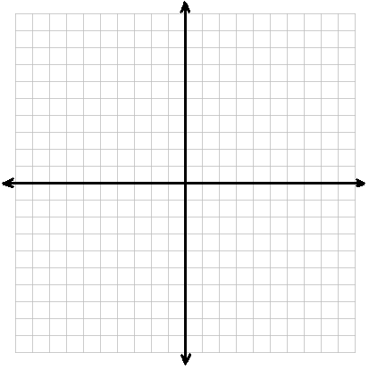 #1. Which of the following are not quadratic functions and why? (2 marks)

Yes or No f(x) = 4 – x2

Yes or No f(x) = 3x3 + 2x2 + 4x + 1

Yes or No y = 3x2 + 2x

Yes or No y = 2x – 1

# of x-intercepts

# of x-intercepts

# of x-intercepts

#2. Given the quadratic function y = (x + 2)2 – 5, fill in the following info: (1 each)

vertex

a) Vertex:

b) Direction the graph opens:

**UP** or **DOWN**

c) Width of graph?

**Normal** **Narrower** **Wider**

d) Is there a Maximum or a Minimum Value?

Maximum Value or Minimum Value

e) Where does the Max/Min occur?

e)

f) Equation of axis of symmetry:

f)

g)

g) Number of x-intercepts:

h)

h) y-intercept:

i) Domain: j) Range:

j) {y|

i) {x|

 k) Sketch the graph. **(2)** **Label the axes, the vertex, and the y-intercept.**

#3. Given the quadratic function f(x) = 2(x – 2)2 – 8, find the x and y intercepts without graphing. (3 marks)

y-intercept

x-intercepts

#4. Determine the number of x-intercepts (without graphing the exact quadratic) of: include diagram! (6)

a) y = 3(x + 5)2 – 1 b) y = 2x2 – 5 c) y = -3(x – 1)2 – 2

#5. Write the new equation of the parabola y = x2 after the following: (3 marks)

a) a horizontal translation 3 units to the right and a vertical translation 3 units up

b) a vertical translation 2 units down and a reflection across the x-axis

c) a multiplication of the y-values by 3 and then a horizontal translation 1 unit to the left

#6. The path of a rocket fired over a lake is described by the function h(t) = -4.9(t – 5)2 + 124 where h(t) is the height of the rocket, in metres, and t is the time in seconds, since the rocket was fired.

a) What is the maximum height reached by the rocket? (1)

Max height

b) How many seconds after it was fired did the rocket reach this height? (1)

seconds

c) How high was the rocket above the lake when it was fired? (2 marks) You must calculate for full marks.

height

d) At what time does the rocket hit the ground? (3 marks)

You must calculate for full marks.

time

e) State the domain and range. (3 marks)

Domain: Range:

f) How high was the rocket after 7s? Was it on its way up or down? (2 marks)

height

/38

Up or down

#7. Given the quadratic function y = -x2 + 2x + 15, fill in the following info:

a) Graph opens (Up or Down) : (1 mark)

b) y-intercept: (1 mark)

c) Vertex : Show your work. (2 marks)

(____, ____)

d) x-intercepts: (show your work) (2 marks)

#8. Change the following into vertex-graphing form by completing the square:

a) y = x2 + 3x + 1 (2 marks) b) y = -2x2 + 8x – 1 (3 marks)

b)

a)

#9. The path a basketball shot takes can be modeled by the function h(d) = -0.08d2 + 0.6d + 2.1 where h(d) is the height, in metres, of the ball and “d” is the horizontal distance, in metres, the ball has travelled since it left the shooter’s hand.

a) Without graphing, what is the maximum height of the ball? (2 marks)

b) How far has the ball travelled horizontally from where it was shot to when it reaches its maximum height? (2 marks) **{Hint: Use info from part a) to calculate b)}**

#10. Given the following graph of a quadratic function, write the equation in vertex-graphing form. (3 marks)

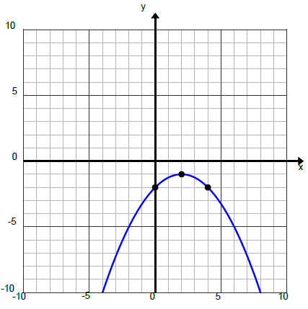

#11. A large hotel is considering giving the following group discount on room rates: the regular price of $120 decreases by $2 for each room rented. For example, one room costs $118, two rooms cost $116 x 2=$232, three rooms cost $114 x 3=$342 and so on.

a) Write a quadratic function with the revenue (R) as a function of the number of rooms (x). (2 marks)

b) Determine the maximum revenue and the corresponding number of rooms rented. (2 marks)

/22

# of rooms

Max revenue