Chapter 7 Review
Trigonometry of Right Triangles
Name_________________________________________
1. Given the following diagram, use the lettering provided to state three Pythagorean relations that apply.
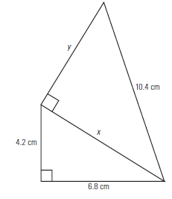
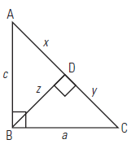
2. Rearrange the Pythagorean Theorem to solve first for a and then for b.
a =

b =

3. Use the Pythagorean Theorem to find the lengths of the missing sides of the triangles to the nearest tenth of a unit.
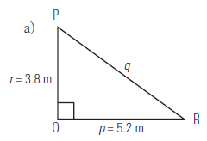

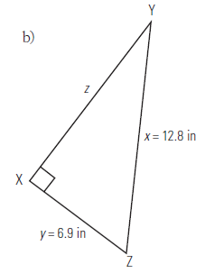

4. Calculate the values of x and y.

5. A field is 120 m by 180 m. How much shorter is your route if you walk diagonally across the field rather than walking around the edge to the opposite corner?

6. Use your calculator to determine the value of each of the following ratios to four decimal places.
7. Calculate the angle to the nearest degree.
8. Determine the unknown measure.
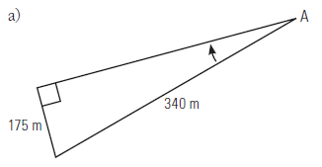
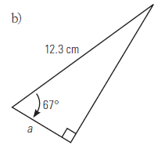
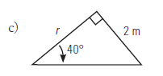
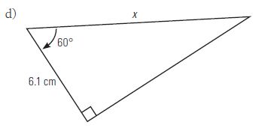
9. Solve the given triangle without using the Pythagorean Theorem.
M =
L =
l =

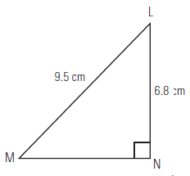

10. Two buildings are 18.5 metres apart. The angle of elevation from the top of one building to the top of the other is 18°. If the taller building is 15 metres tall, how tall is the shorter building?

11. At what angle to the ground must you place a support beam if it is 6.8 metres long and must reach 4.2 metres up the side of a tower?

12. The horizontal distance between two clothesline poles is 3.4 metres. When wet clothes are hung in the middle of the line, it sags at an angle of depression of 6°. How long is the clothesline?

13. A 1.7-metre tall man stands 12 m from the base of a tree. He views the top of the tree at an angle of elevation of 58°. How tall is the tree?

14. A stairway rises 6 feet 4 inches over a horizontal distance of 8 feet 6 inches. What is the diagonal length of the stairway?

15. An airplane starts descending at an angle of depression of 5°. If the horizontal distance to its destination is 500 kilometres, what is the actual distance the airplane will travel before it lands?

16. How high is a weather balloon tied to the ground if it is attached to a 15-metre string and the angle between the string and the ground is 35°?

17. The angle of elevation of a slide that is 3.6 metres long is 32°. How high above the ground is the top of the slide?

18. How far from the base of the house is the foot of a ladder if the angle of elevation is 70° and it reaches 15 feet up the side of the house?

19. The advertised size of a TV screen is the distance between opposite corners. Sally bought a 52-inch TV. If the height of the TV is 32 inches, how wide is it?

20. What is the slant height of a cone if the diameter is 20 centimetres and the angle made with the diameter is 65°?

21. Reba walks 25 yards across the diagonal of a rectangular field. If the angle between the width and the diagonal is 67°, how wide is the field?

22. Determine the angle of elevation to the top of a 5-metre tree at a point 3 metres from the base of the tree.

23. Find the values of a, b, c, and d. Round your answers to the nearest whole degree.
