Math Pre-Calc 20 - Chapter 8 Review
#1. Draw pictures to show the possible solutions to a linear-quadratic system of equations. (2 marks)
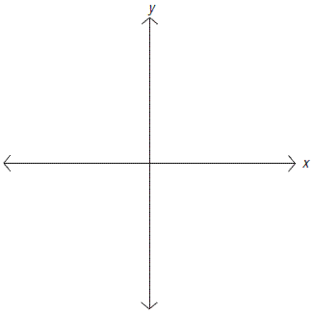

#2. Solve the system below by graphing. Verify your solutions. (4 marks)
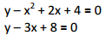

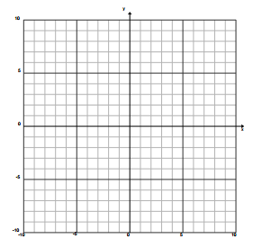

#3. Solve the system below by graphing. Verify your solutions. (4 marks)
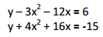

#4. A model rocket is launched from a field. The height of the rocket, “y”, in feet above the ground, after “x” seconds is modeled by the equation y = -16x² + 177x + 4. From the 10th floor of a nearby building, a boy looks out a window when he hears the rocket fired. The boy’s line of sight is given by the equation y = 65x + 100. Approximate the points of intersection and interpret these points. (2 marks)
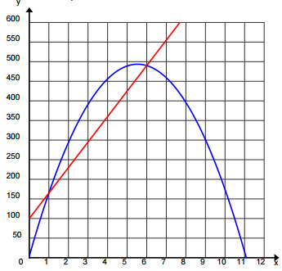

#5. Solve the system below algebraically. You DO NOT need to verify your solutions. (4 marks)
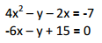

#6. Solve the system below algebraically. You DO NOT need to verify your solutions. (4 marks)
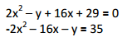

#7. Solve the system below algebraically. Round your answers to 2 decimal places. You DO NOT need to verify your solutions. (4 marks) Hint: You will need to use the quadratic formula!
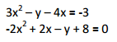

#8. Determine two whole numbers such that the first number increased by triple the second number is 24. If the first number is squared and decreased by five times itself, the result is 13 less than the second number. (5 marks)

#9. Two players are throwing basketballs back and forth. Standing about 9m apart and facing each other, each player throws a ball at the same time. In one exchange, the path of one basketball is represented by the equation y = -x ² +12x – 28. The path of the other ball is modeled by the equation y = -x ² + 4x + 2. In each equation, “x” is the horizontal distance a ball travels, in metres, and “y” is the vertical distance travelled, also in metres. Determine the point(s) of intersection (rounded to 2 decimal places) algebraically and interpret the solution. (4 marks)

