Foundations 20
FINAL EXAM REVIEW
Ch 1 - INDUCTIVE & DEDUCTIVE REASONING
- True or False?
A conjecture is a testable expression that is totally proven to be true.
A conjecture is considered proven only when it has been shown true for ALL cases
A counter example validates a conjecture.
Deductive reasoning starting with a general assumption known to be true and through logical reasoning, drawing a conclusion
Inductive reasoning is making an observation or conclusion based on patterns.
Some conjectures initially seem valid but after more evidence has been gathered, are shown not to be.
The less support you have for a conjecture, the stronger it is.
If you have more than 10 pieces of data that supports your conjecture, you can consider it proven.
If you can’t find a counter example then you can assume your conjecture is true for all cases.
A single counter example is enough to disprove a conjecture.
Division by zero always creates an error in a proof.
Circular reasoning is a reliable way to prove your conjecture.

- Make a conjecture about the sum of one odd integer and one even integer. Test your conjecture with at least three examples.

- Paula claims that whenever you square an odd integer, the result is an odd number. Is her conjecture reasonable? Justify your decision.

- Jarrod discovered a number trick in a book he was reading: Choose a number. Double it. Add 6. Double again. Subtract 4. Divide by 4. Subtract 2. Try the trick several times. Make a conjecture about the relation between the number picked and the final result.

- Prove Jarrod’s number trick deductively.

- Prove that the difference between the square of any odd integer and the integer itself is always an even integer

- Examine the following example of deductive reasoning. Why is it faulty?
Given: Khaki pants are comfortable. Comfortable pants are expensive.
Adrian’s pants are not khaki pants. Deduction: Adrian’s pants are not expensive.

Why is it faulty?

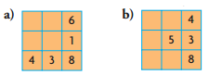
- Fill in the missing numbers, from 1 to 9, so that the sum of the numbers in each row, column, and diagonal is 15.

- Andy, Bonnie, Candice, and Darlene are standing in line to buy ice cream. Determine the order in which they are lined up, using these clues:
Candice is between Andy and Bonnie.
Darlene is next to Andy.
Bonnie is not first.

Ch 2 - Properties of Angles & Triangles
- Fill In the blanks.
The sum of the measures of the interior angles is _____
If lines are //, then corresponding angles are ________
A line that intersects two or more lines is a __________
______ angles lie inside two parallel lines.
Exterior angles lie _________ two parallel lines.
___________ angles share the same position relative to the // lines and transversal.
________ __ angles are two non-adjacent interior angles on opposite sides of the transversal and are ________.
If lines are //, then same side interior angles are ______

- What 4 situations will PROVE that two lines are parallel?

- Which situation does NOT PROVE lines parallel?

- For each diagram, decide if the given angle measures prove that the blue lines are parallel. Justify your decisions

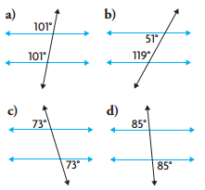

- Determine the measure of each indicated angle
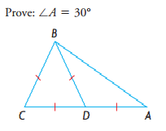
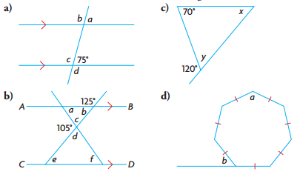

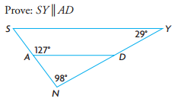

- Determine the values of a, b, and c
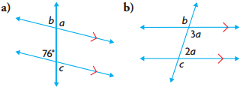
- Determine the values of x, y, and z
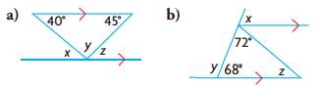

- Determine the sum of the measures of the angles in a 20-sided convex polygon.

- The sum of the measures of the interior angles of an unknown polygon is 3060°. Determine the number of sides that the polygon has.

- Each interior angle of a regular convex polygon measures 140°.
a) Prove that the polygon has nine sides.
b) Verify that the sum of the measures of the exterior angles is 360°.
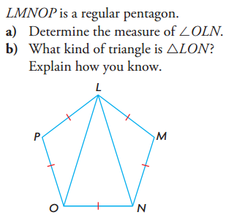

- Three exterior angles of a convex pentagon measure 70°, 60°, and 90°. The other two exterior angles are congruent. Determine the measures of the interior angles of the pentagon.

- Determine the sum of the measures of the indicated angles.

- In each figure, the congruent sides form a regular polygon. Determine the values of a, b, c, and d.
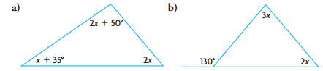
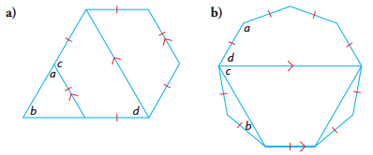
- Determine the value of x in the following diagrams.

Ch 3 & 4 Acute & Obtuse Triangles

- Determine the unknown measures.
- A triangle has angles measuring 80° and 55°. The side opposite the 80° angle is 12.0 m in length. Determine the length of the side opposite the 55° angle to the nearest tenth of a metre.

- The captain of a small boat is delivering supplies to two lighthouses. His compass indicates that lighthouse A to his left is located at N30°W (9km away) and lighthouse B to his right is located at N50°E. Determine the compass direction he must follow when he leaves lighthouse B for lighthouse which are 12 km apart.

- A telephone pole is supported by two wires on opposite sides. At the top of the pole, the wires form an angle of 60°. On the ground, the ends of the wires are 15.0 m apart. One wire makes a 45° angle with the ground.
a) Draw a diagram of this situation.
b) How long are the wires, and how tall is the pole? Express your answers to the nearest tenth of a metre
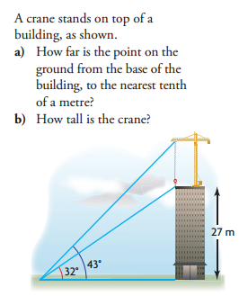

- A parallelogram has adjacent sides that are 11.0 cm and 15.0 cm long. The angle between these sides is 50°. Determine the length of the shorter diagonal to the nearest tenth of a centimetre.

- Allison is flying a kite. She has released the entire 150 m ball of kite string. She notices that the string forms a 70° angle with the ground. Marc is on the other side of the kite and sees the kite at an angle of elevation of 30°. How far is Marc from Allison, to the nearest tenth of a metre?

- A canoeist starts from a dock and paddles 2.8 km N34°E. Then she paddles 5.2 km N65°W. What distance, and in which direction, should a second canoeist paddle to reach the same location directly, starting from the same dock? Round all answers to the nearest tenth of a unit.

- Determine two angles between 0° and 180° that have each sine ratio.
- Determine each unknown angle measure to the nearest degree and each unknown side length to the nearest tenth of a centimetre.
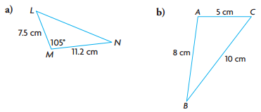
……………………ambiguous case………………………………
- Leanne and Kerry are hiking in the mountains. They left Leanne’s car in the parking lot and walked northwest for 12.4 km to a campsite. Then they turned due south and walked another 7.0 km to a glacier lake. The weather was taking a turn for the worse, so they decided to plot a course directly back to the parking lot. Kerry remembered, from the map in the parking lot, that the angle between the path to the campsite and the path to the glacier lake measures about 30°. What compass direction should they follow to return directly to the parking lot?

- Two workers are helping a crane operator lower a crate to the ground. The workers are standing in line with the crate and each other. Each of them has a rope attached to the crate. The first worker has a 35 ft rope that makes an angle of 50° with the ground. The second worker has a 30 ft rope. Determine the distance, to the nearest foot, between the two workers.
Ch 5 - Statistics
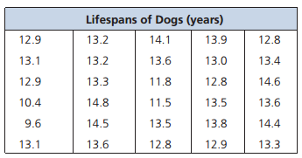
- In a study of the longevity of a particular breed of dog, veterinarians recorded the lifespans of 30 dogs.
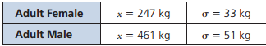
- Calculate the mean, median & mode of this data.
- Create a frequency table & histogram.
- Does the data approximate a normal distribution?
- Determine the range and standard deviation. Describe what these measures tell you about the data.

- Judy always waits until her gas tank is nearly empty before refuelling. She keeps track of the distance she drives on each tank of gas. The distance varies depending on the weather and the amount she drives on the highway. The distance has a mean of 824 km and a standard deviation of 28 km.
a) Sketch a normal to represent this scenario.
b) What percent of the time does Judy drive between 796 km and 852 km on a tank of gas?
c) What percent of the time does she drive between 740 km and 796 km on a tank of gas?
d) Between what two values will she drive 95% of the time?

- Zac is 195 cm tall. In a recent survey of students at his school, it was determined that the heights of the students are normally distributed, with a mean of 170 cm and a standard deviation of 12.5 cm.
a) What percent of the students at Zac’s school are shorter than Zac?
b) What percent of the students are taller than Zac?
- Computers For All offers an extended 3-year replacement warranty on its computers. The mean lifespan of its computers is 3.8 years, with a standard deviation of 0.45. Everything Electronic offers a 2-year replacement warranty on its computers. The mean lifespan of an Everything Electronic computer is 2.6 years, with a standard deviation of 0.31. Which computer is more likely to fail before its warranty period is over?

- Scientists monitor the masses of polar bears. In 2010, the following data was obtained:
The masses of two polar bears were measured. The female had a mass of 277 kg, and the male had a mass of 499 kg. Use z-scores to determine which bear had the greater mass compared with other bears of the same sex.
- From May 29 to June 3, 2010, Nanos Research conducted a random telephone survey of 1008 Canadians, 18 years of age and older, to ask the following question: What are the most important issues facing Canadians today? The responses are shown in the table.
a) What is the margin of error for this survey?
b) Determine the confidence level for this survey.
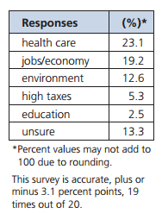
c) State the confidence interval for each of the following responses.
i) health care
ii) environment

Ch 6 – Linear Inequalities

- Graph each system of inequalities. Indicate the solution to the system by shading the
appropriate region.
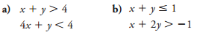
- Consider the following graph of a system of
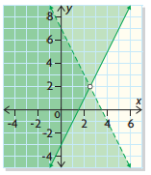
linear inequalities

Determine the linear system that is represented

- A banquet room is set up to seat, at most, 660 people. Each rectangular table seats 12 people, and each circular table seats 8 people.
a) Define the variables and write a linear inequality to represent the number of each type of table needed. Then graph your inequality.
b) The organizers of the banquet would like to have as close to the same number of rectangular tables and circular tables as possible. What combination of tables could they use? Explain your choice.

- Nick is preparing a tomato and red pepper soup as the daily special for his restaurant.
• To allow the red pepper taste to dominate, he will include at least twice as many peppers as tomatoes, by mass.
• However, he wants no more than 25 kg of tomatoes and red peppers altogether.
a) Define the variables and write a system of inequalities to model this situation.
b) Graph the system. Use your graph to suggest
three possible combinations of tomatoes and
peppers.

- Ribbon flowers and crepe-paper rosettes are being made as decorations.
• At least 50 ribbon flowers and no more than 75 rosettes are needed.
• Altogether, no more than 140 decorations are needed.
• Each ribbon flower takes 6 min to make, and each rosette takes 9 min to make.
What combination of ribbon flowers and rosettes will take the least amount of time to make? What is the minimum time needed to make these decorations?

- A transportation company leases vehicles.
• It has 10-passenger vans and 16-passenger minibuses to lease.
• At most, 5 minibuses are available to lease.
• There are 120 or fewer people to be transported.
• Each minibus plus a driver costs $730 to lease, and each van plus a driver costs $550.
What combination of vans and minibuses will allow the transportation company to maximize the value of the leases? What will the maximum value be? How many people can be transported?

- L&G Construction is competing for a contract to build a fence.
• The fence will be no longer than 50 yd and will consist of narrow boards that are 6 in. wide and wide boards that are 8 in. wide.
• There must be no fewer than 100 wide boards and no more than 80 narrow boards.
• The narrow boards cost $3.56 each, and the wide boards cost $4.36 each.
Determine the maximum and minimum costs for the lumber to build the fence

- Sophie has two summer jobs.
• She works no more than a total of 32 h a week. Both jobs allow her to have flexible hours but in whole hours only.
• At one job, Sophie works no less than 12 h and earns $8.75/h.
• At the other job, Sophie works no more than 24 h and earns $9.00/h.
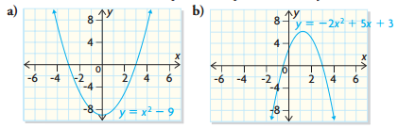
What combination of numbers of hours will allow her to maximize her earnings? What can she expect to earn?

Ch 7 – Quadratic Functions

- i) Express each quadratic function in factored form, and determine
• the x-intercepts.
• the equation of the axis of symmetry.
• the coordinates of the vertex.
• the y-intercept.
ii) Sketch the graph of each function.
iii) State the domain and range of each function.
- i) For each quadratic function, determine
• the equation of the axis of symmetry.
• the coordinates of the vertex.
• the y-intercept.
ii) Sketch the graph of each function.
iii) State the domain and range of each function.

- The parabola f (x) = 4x² + 24x + 31 has x = -3 as its axis of symmetry.
a) Does the parabola open up or down? Explain.
b) Determine the coordinates of the vertex of the parabola.
c) Does the parabola have a maximum value or a minimum value? Explain how you know.

- Determine the equation of the quadratic function shown below. Express the equation in factored form and standard form.
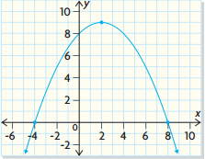

- Determine the roots to each quadratic equation

- Solve each equation.
- Two skydivers jump out of an airplane at an altitude of 4.5 km. Their altitude, in metres, is modelled by the function h(t) = 4500 - 5t² where t is the time in seconds after jumping out of the airplane.
a) Determine the altitude of the skydivers after 5 s.
b) The skydivers opened their parachutes at an altitude of 1500 m. Determine how long they were in free fall.

- A parabola has a y-intercept of -4 and a vertex at (3, -7). Determine the equation of the parabola in standard form.

- A landscaper is designing a rectangular garden, which will be 5.00 m wide by 6.25 m long. She has enough crushed rock to cover an area of 6.0 m² and wants to make a uniform border around the garden. How wide should the border be, if she wants to use all the crushed rock?

