RATIONAL NUMBERS REVIEW

NAME_____________________

1. Write the rational number represented by each letter as a decimal. (2)



A = _______ B = _________ C = ________ D = _______

2. Write the rational number represented by each letter as a fraction. (2)

A = _______ B = _________ C = ________

3. Sketch a number line and mark each rational number on it. Order the numbers from greatest to least. (2)  
–2.25, , –1.5, , 0.9

4. Write the addition statement that each number line represents. (1 each)

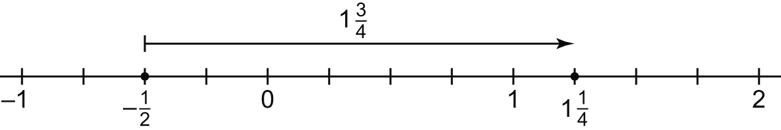

**a)**

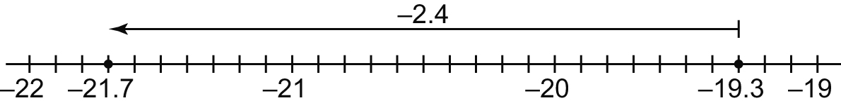

**b)**

5. Determine each sum or difference (8)

**a)**  b) 

**c)**  d**)** 

6. Determine each sum or difference. (8)

**a)**  **b)** 

**c)**  **d)** 

7. Determine each product. (8)

**a)**  **b)** 

**c)**  d**)** 

8. Determine each quotient. (8)

**a)**  **b)** 

**c)**  d**)** 

9. Evaluate.

**a)**  (2)

**b)** 

(4)

10. Sarah borrowed $40.25 from her parents for a new sweater. She earns $17.50 for a night of baby-sitting and gives this to her parents.

**a)** Write an addition statement to represent this situation. (1)

_________________________

**b)** How much does Sarah now owe? (1) ______________________________________

11. Two climbers leave base camp at the same time. Climber A ascends 20.4 m, while climber B descends 35.4 m.

Sketch a diagram to illustrate the situation. (1)

Write a subtraction statement using rational numbers to solve the problem. (1)

_________________________________________________

How far apart are the climbers? (1)

12. From November 12th to November 21st, the temperature in Burnaby, B.C. dropped an average of 1.7°C each day. Suppose the temperature on the morning of November 12th was 11.4°C. What was the temperature on the morning of November 21st? (1)

13. A diver descends 3.2 m in 5 min. What was his average rate of descent in metres per minute? (1)