Workplace and Apprenticeship 10
Final Exam Review

Name: ______________________________
- When he works as a landscape gardener, Mark sometimes uses a powdered fertilizer. It must be mixed at a rate of 1 part of powder to 14 parts of water. How much water will Mark use for 3 litres of powder?

- A car uses 5.5 litres of gas when it travels 100 km.
- Express this as a rate of fuel consumption.

- How much fuel would be needed for a 400-km trip?

- Loretta works as a surveyor near Burwash Landing, YT. Her map uses a scale of 2.5 cm : 100 km. On her map, two sites she must visit are 7.4 cm apart. What is the actual distance between the two sites?

- If a package of 12 pens cost $38.98, what is the cost of 1 pen?

- If the wholesale price of 10 packages of smoked salmon is $99.50, what will the cost be for one package after a markup of 45%?

- The bakery in Lund, BC is selling day-old buns at a 40% reduction. If the regular price is $4.79/dozen, what is the reduced price?

- A sofa in a furniture store was originally $1899.00. The price was “reduced by 35% for quick sale.” When it did not sell, the manager offered another reduction of 20%.
  - What was the final price of the sofa with 5% GST and 7% PST?

  - Is this the same as a 55% reduction? Show why or why not.

- A furniture store in The Pas, Manitoba, advertises: “All weekend, no GST and no PST.” If GST and PST are usually 5% each, what is the actual saving as a percent on an item that costs $24.97?

- James works for an industrial lighting company. He travels to Hong Kong to attend a trade show. James sees a fluorescent track lighting unit priced at 1295.31 Hong Kong dollars. What is the cost in Canadian dollars if $1.00 CAD is worth 7.3181 Hong Kong dollars?

- Marian travels to Spain to visit her mother and father.
  - $1.00 CAD is worth €0.680228. If Marian converts $450.00 CAD into euros, how many euros does she receive?

  - During her visit, Marian buys a leather purse for €125.00. What is the cost in Canadian dollars?

- If Brenda earns $12.15/h and gets a 3.2% raise, how much will she earn per hour?

- How much will you earn in a year as an apprentice metalworker if you are paid $750.00 every two weeks?

- What is your annual salary if your monthly salary is $3568.00?

- As a medical technician, Stephanie has been offered a job that pays $53 000.00 per year and another job that pays $25.50 per hour. Assuming a 40-hour work week and all other conditions being the same, at which job will she earn more?

- Tommy made $20.55 commission on a $685.00 sale. What was his rate of commission?

- Von works as a car salesman. He earns 8% commission on the after-cost profit when he sells a car. If he sells a car for $12 795.00 that cost the dealer $9280.00, how much does he make?

- Jenny earns $12.42/h, but earns double time and a half when she works on a statutory holiday. If she works a 6-hour shift on a holiday, how much will she earn that day?

- Nanette crochets scarves and sells them for $15.95 each. If material cost her $7.52/scarf, how much does she make if she sells 9 scarves?

- Padma has been offered isolation pay of $125.00/week to work as a park ranger in northern Alberta.
  - How much will she make in a 40-hour work week if she is normally paid $21.52/h?

  - Adding in the isolation pay, what is her hourly rate?

- The tallest person in the world was Robert Pershing Wadlow. At the time of his death in 1940, he was 8′ 11.1″ tall. The record for the world’s shortest adult was held by He Pingping; at the time of his death in 2010, he was 2′ 4.7″.
  - What is the difference between their heights in feet and inches?

  - Find the height of each man in metres.

  - What is the difference between their heights in metres?

- Louise needs to give the exterior of a cylindrical granary 2 coats of paint. If the granary is 10 feet tall and has a diameter of 14 feet, and paint covers approximately 375 square feet per gallon, how many gallons of paint will she need to buy? Assume that she can only buy full gallons, and will not be painting the roof.

- Roberto is painting the exterior of a rectangular storage unit to protect it from rusting. If the unit is 4′ 5″ wide, 5′ 6″ long, and 8′ 2″ tall, what is the surface area in square feet? Roberto will be painting the sides and the roof.

- What is the volume of water in a fish tank that is 90 cm by 55 cm if it is filled to a height of 32 cm?

- A driveway is 36 ft long and 10 ft wide, and will be covered in gravel that is 2 in deep. How many cubic yards of gravel will be needed?

- A recipe for pumpkin cheesecake calls for a 5-US fl oz can of evaporated milk.
  - What is this in cups?

  - What is this in mL?

- A welder’s electrical arc has a temperature ranging from 2690°C to 70 000°C. What is this in degrees Fahrenheit?

- Sara buys 8 pounds and 12 ounces of strawberries at $1.98/lb. What is her true cost per pound if 10% of the berries rot before she uses them?

- If 1 bushel is approximately 2220 cubic inches, approximately how many bushels of grain are there in a bin that is 8 feet by 8 feet by 4 feet?

- Estimate, using referents, the size of the angles indicated in the diagrams:
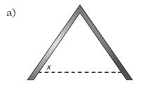
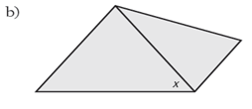
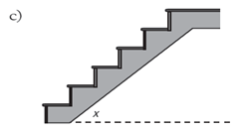
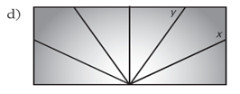

- Draw the following angles AND identify the type of angle: acute, right, obtuse, straight, or reflex:
  - 89˚

  - 101˚

  - 180˚

  - 21˚

  - 331˚

- Measure the following angle and state what its: complement, supplement and the angle after it has been bisected:

b.

- In the diagram below, where t is the transversal and m/n are parallel lines, identify two pairs of each of the following angles.

1 2 m 3 4

⁵ ⁶ ^{n} ⁷ ⁸

t
- Alternate interior angles

- Corresponding angles

- Same side interior angles

- Vertical angles

- Alternate exterior angles

- Same side exterior angles

- In the diagram above find all of the angles if <1 = 102˚ and state the reason.

- Find all angles in the parallelogram:

^{41˚} ¹

2 3

- The lengths of the sides of a pentagon are 2”, 6”, 10”, 14”, and 24”. Calculate the lengths of the sides of a similar pentagon if the shortest side is 5”.

- Determine if the following statements are true or false and explain your reasoning.
a) All equilateral triangles are similar.

b) All isosceles triangles are similar.

c) Any pair of congruent triangles is similar.

- Joanne knitted a blanket that measures 174 cm by 230 cm. Her sister asked Joanne to make a matching one for her son. If Joanne wants to make a similar blanket using a scale factor of 0.55, what will its dimensions be?

- A science teacher uses an overhead projector to display a diagram of a pulley system. The actual diagram is 6”by 7.2”. The image projected onto the wall is 4’2”by 5’. What is the scale factor of the projection?

- A carpenter wants to mix a shade of stain for a set of kitchen cabinets he is building. The ratio for the shade he wants is 3 parts of Spanish oak to 4 parts of red mahogany. If he needs 12 litres in all, how many litres of each stain does he need?

- Calculate the amount of money you would receive in Canadian dollars if you sold the following currencies to a bank.
a) 4500.00 pesos

b) 25 000.00 Hong Kong dollars

c) 2200.00 euros

d) 8545.00 Scottish pounds

- Brenda was hired to replace the wood case moulding on a window frame that measures 90 inches by 48 inches. If the moulding costs $3.25 a linear foot and her labour charge is $8.50 a linear foot, how much will it cost to replace the mouldings?

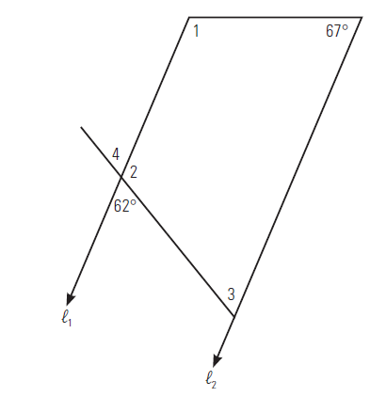
- In the diagram below, ℓ1 is parallel to ℓ2. Determine the measures of the indicated angles and explain your reasons.

- In trapezoid PQRS, PS is parallel to QR. What are the measures of ∠1 and ∠2?
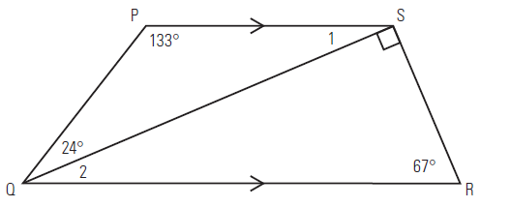

- In the following diagram, AB is parallel to ED, AB is 8 m, AC is 12 m, and CE is 7 m. Calculate ED to one decimal place.
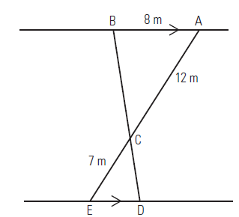

- How high is a weather balloon tied to the ground if it is attached to a 15-metre string and the angle between the string and the ground is 35°?

- A lifeguard sits in a chair that is 2.5 metres high. He spots a child in trouble in the water at an angle of depression of 23°. How far out from the chair is the child?

- What is the angle of elevation of a playground slide that is 1.2 m high and has a horizontal length of 2.6 m?

- Find the indicated angle in each of the following diagrams.
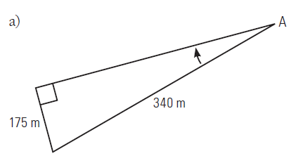
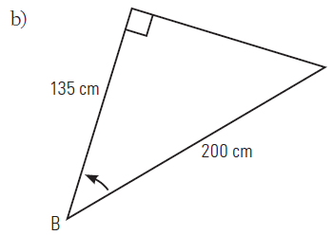

- Find the values of a, b, c, and d.
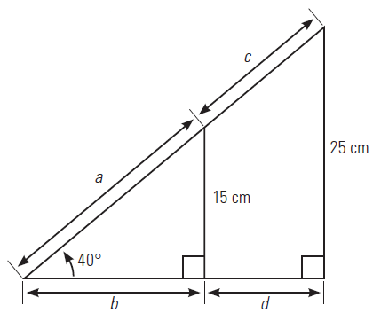

- What height is a pole, and how far away from it is a cable attached to the ground, if the angle of elevation is 25° and the cable is 18 m long?
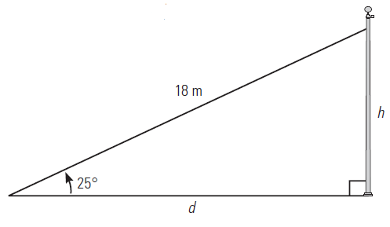

Answers:
      - 42 L
      - A)5.5L/100km
B) 22L
      - 296 km
      - $3.25
      - $14.43
      - $2.87
      - A) $1105.98
B) $957.10
      - 9.1%
      - $177
      - A) 306.10 euros
B) $183.76
      - $12.54/hr
      - $19500/yr
      - $42 816/yr
      - $25.50/hr pays more
      - 3%
      - $281.20
      - $186.30
      - $75.87
      - A) $985.80
B) $24.65/hr
      - A)6’6.4”
B) Robert = 2.7 m, He = 0.7 m
c) 1.99m
      - 2.3 = 3 cans
      - 184.9 ft²
      - 158400 cm³
      - 2.2 yd³
      - A) 0.6 cups
B) 147.9 mL
      - 4874˚F to 126032˚F
      - 2.20/lb
      - 200 bushels
      - A) 52˚ B) 50˚ C) 40˚ D) x = 115˚, y = 55˚
      - A) acute B) obtuse C) straight D) acute E) reflex
      - A) 48˚, complement - 42˚, supplement - 132˚, bisected - 24˚
B) 124˚, complement – none, supplement - 56˚, bisected - 62˚
      - A)3/6, 4/5
B) 1/5, 3/7, 2/6, 4/8
C) 4/6, 3/5
D) 2/3, 1/4, 5/8, 6/7
E 1/8, 2/7
F) 2/8, 1/7
      - <2 = 78, <3 = 78, <4 = 102, <5 = 102, <6 = 78, <7 = 78, <8 = 102
      - <1 = 139, <2 = 139, <3 = 41
      - 5”, 15”, 25”, 35”, 60”
      - A)True – all angles are 60 and sides are proportional
B) False – angles/sides may not be equal or proportional
C) True – congruent triangles are equal/similar
      - 95.7 cm by 126.5 cm
      - 8.3
      - red mahogany: 6.86 L; Spanish oak: 5.14 L
      - a) $375.49 CAD b) $3211.28 CAD
c) $3477.79 CAD d) $17 057.07 CAD
41.
$270.25

42. ∠2 = 118° ∠3 = 62°
∠4 = 62° ∠1 = 113°
43. ∠1 = 23° ∠2 = 23°
44. ED ≈ 4.7 m
45. about 8.6 m
46. about 6 m
47. about 25°
48. a) ∠A ≈ 31° b) ∠B ≈ 48°
49. a) a ≈ 23 cm b) b ≈ 18 cm
c) c ≈ 16 cm d) d ≈ 12 cm
50. pole height: about 8 m; the cable is attached about 16 m away from the pole.

